**Data Summary:**

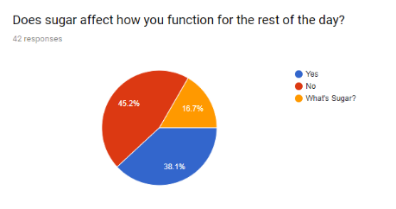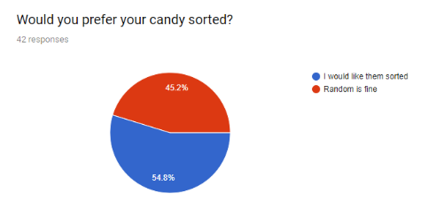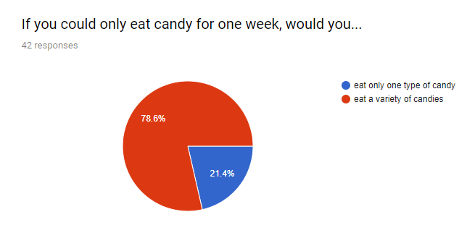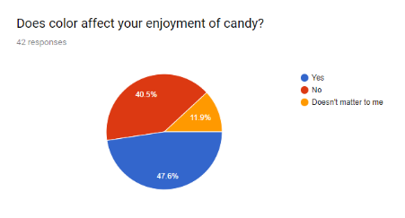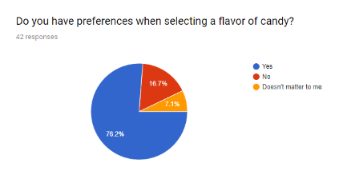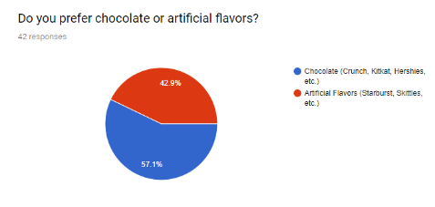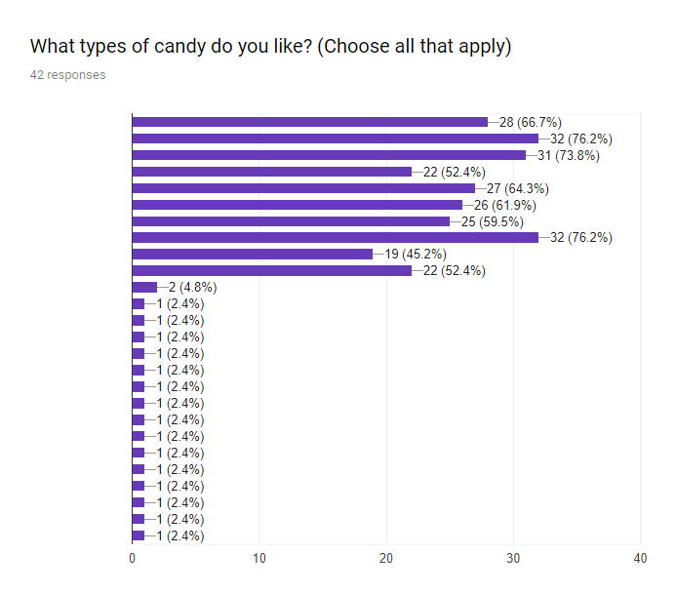Halloween is festive time where children go door to door to receive candy. But problems do arise when they many of them come home. In our society, people have preferences as to which candy they would choose. Due to their pickiness, many people of all ages display preference to which candy they would eat. This preference often introduces a problem as marketers sell candy mixed when there are preferences to which candy one would eat. A candy sorter would organize candy by types and by color and thus reduce the time that people would need to dig through all their candy in order to get the specific one they like.

Our results display that even for teenagers who are not yet adults; they still have some sort of preference to what types of candy are available to them. While this candy sorter is mainly geared towards younger people, the topic of candy preference and the ability to choose which kind to eat is still prevalent for people of all ages. While our results display that the populous enjoys chocolate that has one constant flavor, they still have preference over the colors and what they may represent. Even in situations that have no distinct choices, they would still choose candy depending on their best judgment. However, our research does indicate that candy preference declines as people age so our target audience might not be the ones who were taking the survey. Nevertheless, it is still evident that candy sorting would benefit people’s enjoyment of candy.